Worksheet 27 interference Name
Relevant textbook sections covered: 21.5 - 21.7

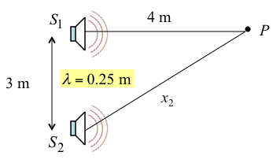
1. Sources out of phase . What is the interference at Point P, constructive, destructive, or somewhere in between?

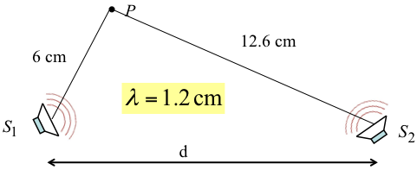
2. Sources in phase . What is the interference at Point P, constructive, destructive, or somewhere in between?

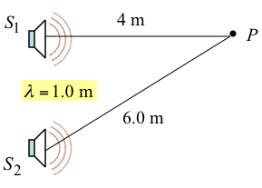
3. Sources out of phase . What is the interference at Point P, constructive, destructive, or somewhere in between?

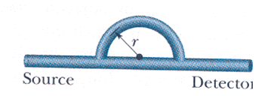
4. Sound waves of 40.0 cm wavelength enter the tube shown in the figure. What must be the smallest radius r so that a minimum in the sound level will be heard at the detector at the other end of the tube? What is the minimum r for which you would hear maximum sound (excluding 0)?

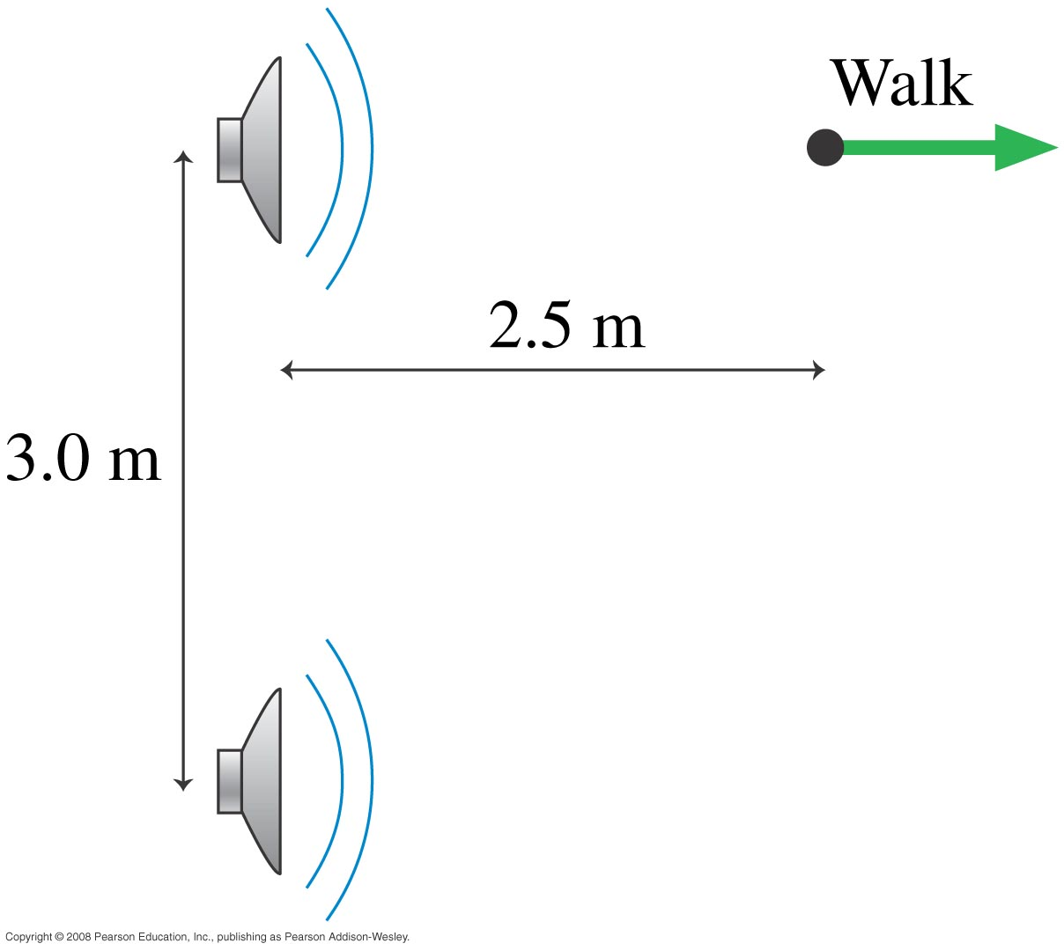
Good practice: You are standing 2.5 m directly in front of one of the two speakers shown in the figure. The speakers are 3.0 m apart and both are playing a 686 Hz tone in phase. As you begin to walk directly away from the speaker, at what distances from the speaker do you hear a minimum sound intensity?

