**Worksheet 25 standing sound waves Name:**

Relevant textbook sections covered: 21.3, 21.4

1. An A-string for a violin, fixed at both ends, has a length of 32.5 cm and linear mass density of 6.1x10-4 kg/m. One of the resonance frequencies of the string is 1320 Hz. The next resonance frequency is 1760 Hz; there are no frequencies between these two.

1. What is the lowest resonance frequency (fundamental) of the A-string?
2. Which harmonic is the 1320 Hz frequency?
3. What is the tension in the string?

2. An open-closed tube of air supports standing waves at frequencies of 600 Hz and 1000 Hz, and at no frequencies between these two. What are the frequency values for m = 1, m = 2, and m = 3? (Think about: do all of these modes exist?)

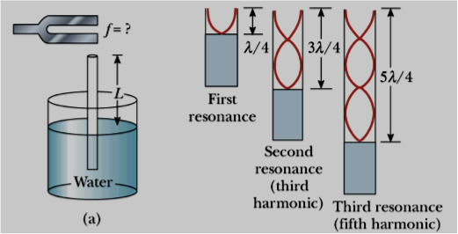

14 cm

3. A tuning fork is held above a column of air as shown. The smallest L-value for which a peak occurs in the sound intensity is 14.00 cm. (Assume: speed of sound in air is 343 m/s).

1. What is the frequency of the tuning fork?
2. What is the value of L for the next two resonance frequencies?

4. **GOOD EXAM PRACTICE**: An open-open metal tube has a fundamental frequency of 600 Hz. If you cut the tube to 2/3 of its original length and close one end, what is the new fundamental frequency of the modified tube?

5. **GOOD EXAM PRACTICE**: Standing waves are set up in a cylindrical tube at 500, 700 and 900 Hz. There are no standing waves at 600 and 800 Hz.

1. What is the fundamental harmonic for this tube?
2. Is the tube open at both ends or close at one and open at the other end?