**Worksheet 23 Superposition and standing sound waves Name:** Relevant textbook sections covered: 21.1, 21.2, 21.3

1. Two pulses are traveling toward each other in opposite direction.

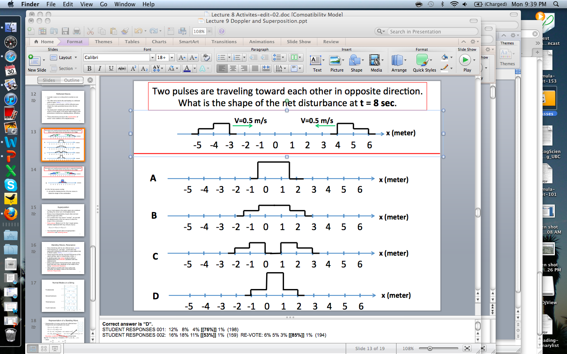Draw the shape of the net disturbance at t = 8 sec.

2. A standing wave on a string vibrates as shown in the figure. Suppose the tension is quadrupled while the frequency and the length of the string are held constant. Draw the standing wave pattern that is produced.

3) Write down three ways to change the pitch of a guitar string.

4) A string of length 1.2 m is fixed at both ends. Which one of the following is NOT a wavelength of a standing wave on the string: 40 cm, 60 cm, 180 cm, 240 cm?

Show your work.

5) **Good exam question:** A guitar string of length L and mass m has a fundamental frequency f = 440 Hz. When the tension is increased by 10%, the string is stretched and its total length increases by 2% but the vibrating length remains L. What is the fundamental frequency now?

HINT: Setting up a RATIO will be very helpful. Think about the different quantities in the problem (and in the real world). Which ones stay constant? Which ones vary?