**Worksheet 6 Buoyancy**  **Name:**

Relevant textbook sections covered: 15.4

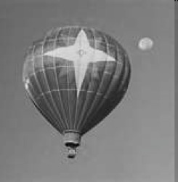**1)** Hot air balloons: Is there a buoyant force in air?

What is the minimum volume of a helium-filled balloon to remain in the sky at one position?

The balloon has a total mass of 80 kg and the density of He and of air are He = 0.179 kg/m3 and air = 1.28 kg/m3; the balloon contains helium at a pressure of 1.0 atm.

Think about:

* For the balloon to remain in one place what would the buoyant force be: greater than, less than, or the same as the total weight of the balloon?
* What needs to be considered as the ‘total weight’ of the balloon?
* Why can a balloon float if it has 1 atm of pressure, just like the atmosphere?

**Explain your reasoning and set up the equation.**

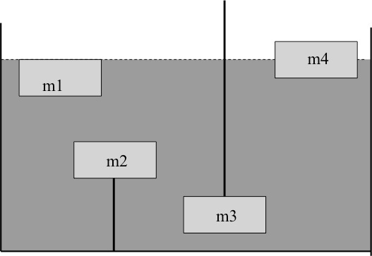

2) The figure shows four objects with identical volume immersed in a fluid. Set up the Net force equations for each object.

Use the variables: f  Vf, , T, Vo, o

3) Consider three identicalopen containers (as shown below).

* Container 1 holds only water
* Container 2 has a piece of wood floating in the water (on the surface)
* Container 3 has a small stone resting on the floor of the container

**C1**

**C2**

**C3**

Compare the total weight of each container (including water and any objects), if each container was placed on a scale. Note that the *water level* in all three containers is the same. **Explain your reasoning in both words and equations.**