**Worksheet 2 Pressure** **Name:**

Relevant textbook sections covered: 15.1 and 15.2

**Instructions:**

Discuss each question in small groups. Write on the back or an additional sheet for more space. When explicitly asked, be sure to explain your reasoning in sentences.

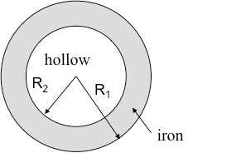1) What is the average density of a spherical shell of iron shown in the figure below? Use **ρFe** = 7870 kg/m3 ;

R1 = 10.0 cm and R2 = 9.0 cm.

Think about: where the mass is located and what is considered the volume.

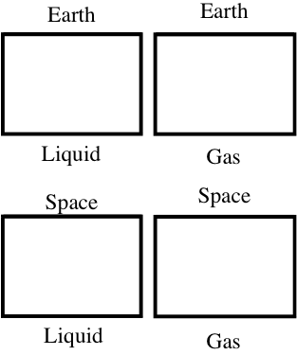

2) The containers to the left are roughly half full with water molecules – the ones on the left contain liquid water and the ones on the right contain gaseous water (steam).

(a) Draw how the molecules would distribute themselves in the containers on Earth and in space.

(b) If there were a pressure meter on the floor of the containers, what would it read? **Explain your answer**.

(c) What factors would lead to a change in pressure?

6) Rank the pressures at points 1 to 5 (from greatest to smallest).

**Defend your answer in words.**

Hint: Compare different parts; are there points where the pressure will be equal?

