Phys 315 - Group Activity #1
Group members:

This activity is intended to connect some of the concepts of quantum mechanics, discussed last week in class, with a real-world application. Please work in groups of 2-4 on this activity.

- Recall that x-rays are produced by converting electrical energy into electromagnetic waves, and can be made by accelerating electrons from an electrically negative cathode towards a positive 'target' anode. When the electrons hit the target they are decelerated rapidly, causing them to lose energy which is converted into heat energy and x-rays. The anode and cathode effectively form a circuit which is completed by the flow of electrons through the vacuum of the tube.

The figures that follow show the resulting spectrum for a tungsten target.

a) If the given curve was produced by a source current of 10 mA, sketch the shape of the curve you'd expect for a source current of 20 mA (assume an unchanged potential difference).

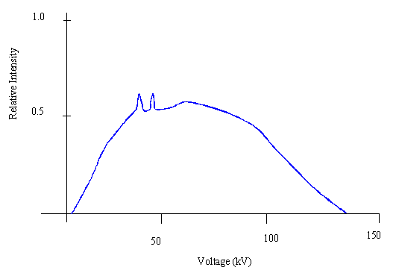

b) If the given curve was produced by a potential difference of 100 kV, sketch the curves you'd expect to get from a potential difference of 150 kV and 30 kV (assume an unchanged source current).

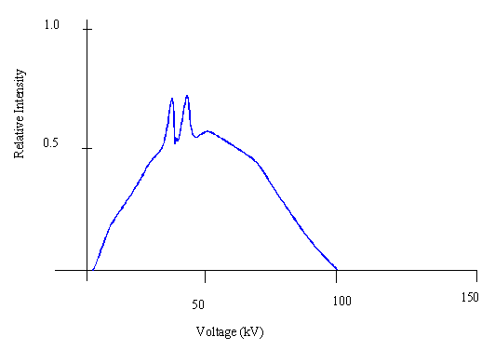

- Unlike light or electron beams, x-rays cannot be focused. As a result, when used for medical imaging purposes, they can only make shadow images. If you were to use a small point source of light, you could get sharp shadow images. Alternatively, if you were to use a wide source of light, your shadow images would become rather 'fuzzy'. For the purposes of medical imaging, doctors want as sharp a shadow image as possible. List some different ways in which the shadow image could be sharpened.

